Department of Computer Science and Technology

Subject Name: Principles of Operating Systems Subject Code: CSH 211

Topic: Memory Management

Tutorial: 10

Aim: To gain familiarity with Memory Management

Q1. Which of the following page replacement algorithms suffers from Belady’s anomaly?
- FIFO B. LRU
- Optimal Page Replacement D. Both LRU and FIFO

Q2. What is the swap space in the disk used for?
- Saving temporary html pages B. Saving process data
- Storing the super-block D. Storing device drivers

Q3. Virtual memory is
- Large secondary memory B. Large main memory
- Illusion of large main memory D. None of the above

Q4. Page fault occurs when
- When a requested page is in memory B. When a requested page is not in memory
- When a page is corrupted D. When an exception is thrown

Q5. Thrashing occurs when
- When a page fault occurs
- Processes on system frequently access pages not memory
- Processes on system are in running state
- Processes on system are in waiting stat

Q7. The aim of creating page replacement algorithms is to:
A. replace pages faster B. Increase the page fault rate
C. decrease the page fault rate D. to allocate multiple pages to processes

Q8. A FIFO replacement algorithm associates with each page the _______
A. time it was brought into memory B. size of the page in memory
C. page after and before it D. All of these

Q9. Optimal page – replacement algorithm is:
A. Replace the page that has not been used for a long time
B. Replace the page that has been used for a long time
C. Replace the page that will not be used for a long time
D. None of these

Q10. Optimal page – replacement algorithm is difficult to implement, because:
A. it requires a lot of information B. it requires future knowledge of the reference string
C. it is too complex D. it is extremely expensive

Q11. LRU page – replacement algorithm associates with each page the ______
A. time it was brought into memory B. the time of that page’s last use
C. page after and before it D. All of these
SECTION-B

Q1. Given page reference string:
1,2,3,4,2,1,5,6,2,1,2,3,7,6,3,2,1,2,3,6
Compare the number of page faults for LRU, FIFO and Optimal page replacement algorithm considering 4 Page frames.
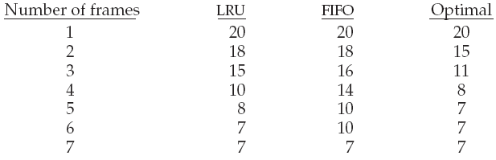

Q2. A process refers to 5 pages, A, B, C, D, E in the order : A, B, C, D, A, B, E, A, B, C, D, E. If the page replacement algorithm is FIFO, the number of page transfers with an empty internal store of 3 frames is : 9

Q3. For 3 page frames, the following is the reference string:
7 0 1 2 0 3 0 4 2 3 0 3 2 1 2 0 1 7 0 1
How many page faults does the LRU page replacement algorithm produce?
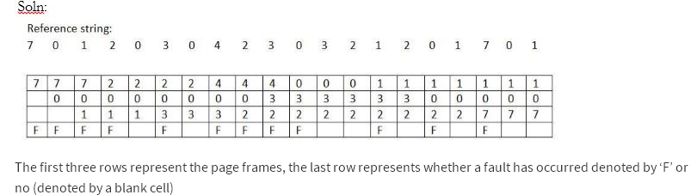

Q4. If the hit ratio to a TLB is 80% and it takes 15 nanoseconds to search the TLB, and 150 nanoseconds to access the main memory, then what must be the effective memory access time in nanoseconds? 195

Q5. In a paging system with TLB, it takes 30 ns to search the TLB and 90 ns to access the memory. If the TLB hit ratio is 70%, find the effective memory access time. What should be the hit ratio to achieve the effective memory access time of 130 ns?
Solution
Time taken in case of TLB hit = Time to access TLB + Time to access memory
= 30 + 90 = 120 ns
Time taken in case of TLB miss = Time to access TLB + Time to access page table + Time to
access memory
= Time to access TLB + 2(Time to access the memory location)
= 30 + 2 (90) = 210 ns

Effective memory access time (EAT) = P(H) × (Time to access TLB + Time to access
the memory location) + [(1−P(H)) × (Time to access TLB + 2(Time to access the
memory location))]
= 0.70 x 120 + 0.30 x 210 = 147 ns
Next, let us calculate the hit ratio when EAT is 130 ns.
130 = P(H) x 120 + ((1-P(H)) x 210)
130 = P(H) x 120 + 210 – 210 x P(H)
90 P(H) = 80
P(H) = 0.89
P(H) = 89%
Therefore, to reduce EAT to 130 ns, the hit ratio should be increased to 89%.

Q6. Consider a system with 80% hit ratio, 50 nano-seconds time to search the TLB, 750 nano-seconds time to access memory.
Find the time to access a page
a. When the page number is in associative memory.
b. When the time to access a page when not in associative memory.
c. Find the effective memory access time.

Ans:
a. The time required is
50 nano seconds to get the page number from associative memory and 750 nano-seconds to read the desired word from memory.
Time = 50+750= 800 nano seconds.

b. Now the time when not in associative memory is
Time = 50+750+750= 1550 nano seconds
One memory access extra is required to read the page table from memory.

c. Effective access time = Page number in associative memory + Page number not in associated memory.
Page number in associative memory = 0.8 * 800.
Page number not in associated memory = 0.2 * 1550.
Effective access time = 0.8 * 800 + 0.2 * 1550 = 950 nano seconds

Q.7 Consider the segment table below. What are the physical addresses for the following logical addresses?
a. 0,430 b. 1, 10 c. 1, 11 d. 2, 500

Segment | Base | Length
0 | 219 | 600
1 | 2300 | 14
2 | 90 | 100
3 | 1327 | 580
4 | 1952 | 96

Ans:
a. 219+430 = 649.
b. 2300+10=2310.
c. 2300+11=2311
d. Illegal address since size of segment 2 is 100 and the offset in logical address is 500.

